FP7-‐314151 EMERALD Project
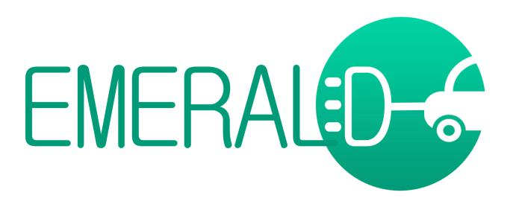

The V2G interface according to ISO/IEC 15118


Dissemination Level: |  | PU
Nature of the Deliverable: |  | R
Date: | 23/05/2016
Distribution: |  | WP6
Editors: |  | Aurelio Díaz de Arcaya -‐ Tecnalia
Contributors: |  | Reviewed by Cosmote

* Dissemination Level: PU= Public, RE= Restricted to a group specified by the Consortium, PP= Restricted to other program participants (including the Commission services), CO= Confidential, only for members of the Consortium (including the Commission services)
** Nature of the Deliverable: P= Prototype, R= Report, S= Specification, T= Tool, O= Other


Abstract: The bidirectional communication between the electric vehicle andthe grid operator is one of the crucial steps in the smart grids. This communication makes it possible to dynamically respond to changes in grid condition. The interface of communication is commonly indicated as V2G and includes a wide range of demand-‐responsive energy services as the contribution in the stability grid, peak load leveling of the grid and allowing some kind of saving to electric vehicles owners. This white paper describes the specification for the V2G according to IEC/ISO 15118 as a new alternative of the communication between EMERALD services and the grid operator.
The V2G interface according to ISO/IEC 15118

Disclaimer
This document contains material, which is copyright of certain EMERALD consortium parties and may not be reproduced or copied without permission. The information contained in this document is the proprietary confidential information of certain EMERALD consortium parties and may not be disclosed except in accordance with the consortium agreement.

The commercial use of any information in this document may require alicense from the proprietor of that information.

Neither the EMERALD consortium as a whole, nor any certain party of theEMERALD consortium warrant that the information contained in this document is capable of use, or that use of the information is free from risk, and accept no liability for loss or damage suffered by any person using the information.

FP7-‐314151 EMERALD Project Page 2 of 20
The V2G interface according to ISO/IEC 15118

Revision History


 |  | Date |  |  |  |  | Rev. |  |  | Description
 |  | 15/05/2015 |  |  |  |  | 01 |  |  | Draft
 | 23/05/2016 |  |  |  |  | 02 |  |  |  | Document reviewed according to comments (from Cosmote partner)

FP7-‐314151 EMERALD Project Page 3 of 20
The V2G interface according to ISO/IEC 15118

List of Authors


 |  | Partner |  |  |  |  | Author
 |  | Tecnalia |  |  |  |  | Aurelio Díaz de Arcaya, Valentín Sánchez

FP7-‐314151 EMERALD Project Page 4 of 20
The V2G interface according to ISO/IEC 15118

Table of Contents

Revision History............................................................................................................................................ |  |  | 3
List of Authors .............................................................................................................................................. |  |  | 4
Table of Contents ......................................................................................................................................... |  |  | 5
Index of figures............................................................................................................................................. |  |  | 6
Index of tables.............................................................................................................................................. |  |  | 7
Glossary |  | ........................................................................................................................................................ | 8
Executive Summary...................................................................................................................................... |  |  | 9
1. | Introduction ....................................................................................................................................... |  | 10
2. | Architecture of ISO/IEC 15118 V2IoG................................................................................................. |  | 12
3. | Proposal of basic architecture over ISO/IEC 15118............................................................................ |  | 15
4. | Interaction between V2G and the electric grid.................................................................................. |  | 16
5. | EMERALD approach using ISO/IEC 15118 Value Added Services....................................................... |  | 17
 | 5.1 | Added value services over ISO/IEC 15118.................................................................................. | 17
 | 5.2 | Emerald approach ...................................................................................................................... | 17
 | 5.3 | Fraunhofer example ................................................................................................................... | 17
6. | Conclusions ........................................................................................................................................ |  | 19
7. | References.......................................................................................................................................... |  | 20

FP7-‐314151 EMERALD Project Page 5 of 20
The V2G interface according to ISO/IEC 15118

Index of figures

Figure 1. Pilot signal states 10

Figure 2. ISO/IEC 15118 actors [3] 12

Figure 3. PLC communication on Control Pilot Line (CPLT) [5] 15

Figure 4. The INSYS Power line GP as a commercial solution [6] 15

Figure 4. Fraunhofer ESK demonstrating vehicle-‐to-‐grid communications based on ISO/IEC 15118 and IEC

61850 standards. 18

FP7-‐314151 EMERALD Project Page 6 of 20
The V2G interface according to ISO/IEC 15118

Index of tables

Table 1. List of vehicle states 11

Table 2. List of charging scenario 14

Table 3. Typical Data Exchanged over the Vehicle-‐to-‐Grid Interface 14

FP7-‐314151 EMERALD Project Page 7 of 20
The V2G interface according to ISO/IEC 15118

Glossary


COSEM |  | Companion Specification for Energy Metering
CPLT |  | Control Pilot Line
DER |  | Distributed Energy Resources
DLMS |  | Device Language Message Specification
EV |  | Electric Vehicle
EVCC |  | Electric Vehicle Communication Controller
EVSE |  | Electric Vehicle Supply Equipment
EXI |  | Efficient XML Interchange
FEV |  | Full Electric Vehicle
HPGP |  | HomePlug Green PHY
IP |  | Internet Protocol
OBU |  | On-‐Board Unit
OCPP |  | Open Charge Point Protocol
OSI |  | Open Systems Interconnection
PCF |  | Pilot Control Function
PLC |  | Power Line Communication
SECC |  | Supply Equipment Communication Controller
SLAC |  | Signal Level Attenuation Characterization
SOAP |  | Simple Object Access Protocol
TCP |  | Transmission Control Protocol
TLS |  | Transport Security Layer
UDP |  | User Datagram Protocol
V2G |  | Vehicle to Grid
V2GTP |  | Vehicle-‐to-‐Grid Transfer Protocol
V2IoG |  | Vehicle to Infrastructure over Grid
XML |  | eXtensive Mark-‐up Language

FP7-‐314151 EMERALD Project Page 8 of 20
The V2G interface according to ISO/IEC 15118

Executive Summary

In the context of the EU funded R&D project EMERALD (http://www.fp7-‐emerald.eu/), the vehicle-‐to-‐grid batch data synchronization constitutes a novel functionality, considering the possibility of using power line communication as a possible way to provide electric vehicles with wired connectivity when they are plugged-‐in for recharging.

The wired powerline communication can be a reliable and cost-‐effective alternative to the existing wireless communication technologies. The availability of this connectivity in recharging stations together with the technological advancements of power line communication, will enable massive data synchronization while the vehicle is not in use during a charging period in order to acquire, via machine-‐learning techniques, the knowledge to calculate energy efficient routes.

This document describes the specification for the V2G according to IEC/ISO 15118, considering a proposal of basic architecture over this standard, added value services over ISO/IEC 15118 and provides potential extensions on the interaction between V2G and the electric grid.

FP7-‐314151 EMERALD Project Page 9 of 20
The V2G interface according to ISO/IEC 15118

1. Introduction

About the EMERALD project: The EMERALD project addresses energy use optimization and the seamless integration of FEVs into the transport and energy infrastructure, by delivering clear advances over the state-‐of-‐the-‐art solutions that have been delivered in a number of earlier FEV-‐related projects (including the direct predecessor of EMERALD, FP7-‐GC EcoGem project) using Information and Communication Technology (ICT) means. With a clear view to commercial exploitation, the projectaims at helping in transforming the current market position of FEVs into a more satisfactory one. For this purpose, a number of novel functionalities have been developed:

- Energy-‐driven management of FEV auxiliaries.

- Energy-‐efficient long-‐range route planning and optimization.

- Performance-‐centric machine-‐learning-‐based consumption prediction.

- Driver profiling data collection.

- Data synchronization using power-‐line communications (V2IoG).

- User-‐centric charge/discharge management.

Supplementary pillars of the project, namely Enhanced power demand prediction and Power flow management support, Cooperative FEV fleet management and FEV-‐oriented driver training also play a

significant role and complement the overall process of energy-‐efficient FEV driving.

The term Vehicle to Grid (V2G) communication refers to the convenient, automated and standardized exchange of information between the vehicle and the grid, which includes two communication links at least, the Pilot Control Function (PCF) and the high-‐level Power Line Communication (PLC).

The PCF and proximity detection is an additional means to increase safety and reliability of the charging process of an electric vehicle and is specified in Annex A of IEC 61851-‐1 [1]. If the plug is removed from the charging port of the vehicle while charging, , the control pilot and proximity detection pins will break first so that the Power Pin relay in the Charging Station will be shut off and no current will flow.
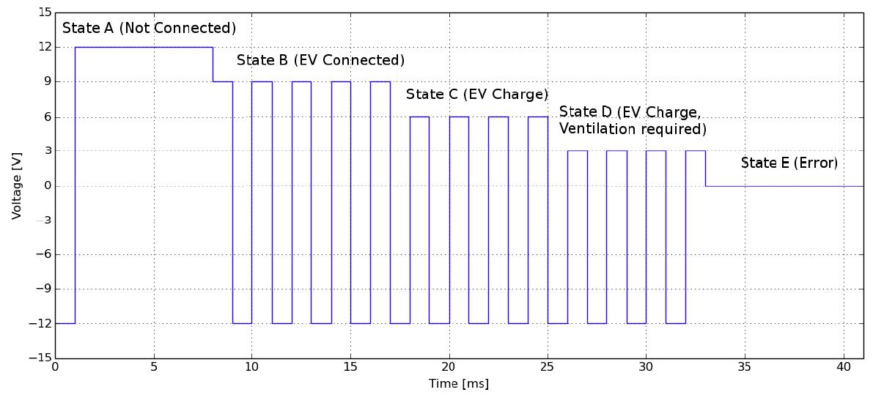

Figure 1. Pilot signal states

FP7-‐314151 EMERALD Project Page 10 of 20
The V2G interface according to ISO/IEC 15118

The function that displays these states is called the vehicle state.

 |  |  |  |  | Table 1. List of vehicle states
Vehicle state |  |  | Voltage |  | Status |  |  | Charging possibility
A |  |  | 12 V |  | Vehicle is not connected |  |  | Not possible
B |  |  | 9 V |  | Vehicle is connected |  |  | Not possible
C |  |  | 6 V |  | Charging is possible. Ventilation unnecessary |  |  | Possible
D |  |  | 3 V |  | Charging is possible. Ventilation necessary |  |  | Possible
E |  |  | 0 V |  | Vehicle is not connected -‐ supply-‐side situation |  |  | Not possible
F |  |  | -‐12 V |  | Vehicle is not connected -‐charger situation |  |  | Not possible

The Vehicle to Infrastructure over Grid (V2IoG)is of particular interest for EMERALD in order to allow for interoperability of the communication between grid infrastructure and the On-‐Board Unit (OBU) of the Full Electric Vehicle (FEV).

The Vehicle-‐to-‐grid batch data synchronization constitutes a novel EMERALD functionality, considering the possibility of using PLC as a possible way to provide FEVs with wired connectivity when they are plugged-‐in for recharging.

The wired powerline communication can be a reliable and cost-‐effective alternative to the existing wireless communication technologies. The availability of this connectivity in recharging stations together with the technological advancements of PLC, will enable massive data synchronization while the vehicle is not in use during a charging period in order to acquire, via machine-‐learning techniques, the knowledge to calculate energy efficient routes.

The protocol family ISO/IEC 15118 [2] is a standard based on PLC. This standard specifies messages to be exchanged between the Electric Vehicle Communication Controller (EVCC) and the Supply Equipment Communication Controller (SECC). The respective protocols depend on the charging mode, charging scenario, or desired identification and authentication methods.

This document reviews the existing draft standards of ISO/IEC 15118 and provides potential extensions for EMERALD project in the vehicle to grid traffic and consumption data synchronization from the V2IoG in order to allow for interoperability of the communication between grid infrastructure and the OBU of the FEV.

FP7-‐314151 EMERALD Project Page 11 of 20
The V2G interface according to ISO/IEC 15118

2. Architecture of ISO/IEC 15118 V2IoG

ISO/IEC 15118 V2G Communication Interface was approved as a new family of communication protocol standards for the charging control of electric vehicles. In April 2014, both 15118-‐1 (general information and use case definition) and 15118-‐2 (network and application protocol requirements) had already been issued as international standards. The rest of the list of ISO/IEC 15118 international standards are currently in progress, 15118-‐3 (physical layer and data link layer requirements), 15118-‐4 (network and application protocol conformance test), 15118-‐5 (physical and data link layer conformance tests), 15118-‐6 (general information and use case definition for wireless communication), 15118-‐7 (Network and application protocol requirements for wireless communication) and 15118-‐8 (physical layer and data link layer requirements for wireless communication).

The actors in the architecture of ISO/IEC 15118 Communication Interface, V2IoG, are grouped into two types: the primary actors that are directly involved in the charging scenario and the secondary actors that are indirectly involved in it.

The primary actors are composed of the EV and the recharging point,namely the Electric Vehicle Supply Equipment (EVSE), while the central primary actors are the communication controllers, i.e., theElectric Vehicle Communication Controller (EVCC) and the Supply Equipment Communication Controller (SECC).

ISO/IEC 15118 prescribes the communication protocol between the EVCC and SECC shown in Figure 2 where a request message is sent indirectly to thesecondary actors through the SECC and it is sent back to the EVCC after the necessary processing.
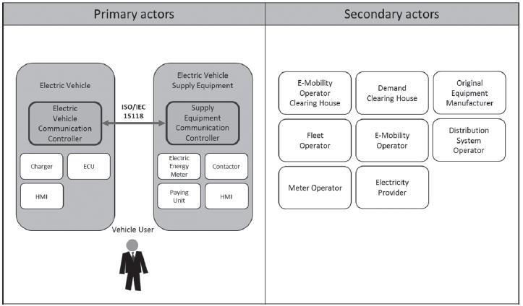

Figure 2. ISO/IEC 15118 actors [3]

The communication system acts as a “clearing house” for the authentication, collection and consolidation of grid and billing parameters from the actors, as well as transmitting charging process

FP7-‐314151 EMERALD Project Page 12 of 20
The V2G interface according to ISO/IEC 15118

information to the respective actors. The increased functionalities allow for active charge control, demand response management, payment processing the list not being exhaustive.

The composition of 15118 protocol is defined by an Open Systems Interconnection (OSI) reference model that has been divided into a hierarchical structureaccording to the scope of responsibilities for each standard.

I. Communication technology (data link layer) and physical layer are represented by two major technologies:

- G3-‐PLC with frequencies below 500 kHz

- IEEE P1901.2 HomePlug Green PHY with frequencies between 2 and 30 MHz (HPGP)

The two possible communication links are,

- The high-‐level PLC between electric vehicles and EVSE

- The PCF.

The Signal Level Attenuation Characterization (SLAC), that measures the signal strength and then makes a judgment about whether there is an actual connection, is able to determine whether that signal was received via a pilot line that was actually connected by measuring this signal or could have been propagated from an adjacent or shared power supply line, which is referred to as cross talk or shared media.

Preliminary theoretical analysis, simulation and physical tests show that HPGP on the pilot line is seen as the most promising technology. This technology provides a high level of robustness for a reliable communication and high data rate.

II. In the network layer, an IP address is obtained to carry out TCP/IP communication.

III. In the transport layer, communication is generally performed using the TCP and the UDP. In the case of TCP, the address of the destination must be specified, while in the case of UDP, a message can be broadcasted without the need to specify the destination. In both cases a Transport Security Layer (TLS) is generally used to encrypt the communication.

IV. In the Session Layer, the Vehicle-‐to-‐Grid Transfer Protocol (V2GTP) is used to specify the communication data structure, header structure, and port address as the message format in the next layer, called the Presentation Layer. Each message is defined with eXtensive Mark-‐up Language (XML) because this is widely used for internet-‐based communication. Efficient XML Interchange (EXI) could be used for the actual sending and receiving of messages to reduce the communication load.

V. In the Application Layer, the set of messages used by the EVCC and SECC for communication is defined in accordance with the charging scenarioof Table 2.

FP7-‐314151 EMERALD Project Page 13 of 20
The V2G interface according to ISO/IEC 15118

 |  | Table 2. List of charging scenario
Group |  | Details
A |  | Start of charging process
B |  | Establishment of communication
C |  | Update and introduction of certificate
D |  | Approval and authentication processing
E |  | Creation of charging plan
F |  | Charging control
G |  | Additional services
H |  | Finishing process

The communication between the EVCC and SECC is of the server-‐to client type and the messages are sent from the EVCC.

 |  |  | Table 3. Typical Data Exchanged over the Vehicle-‐to-‐Grid Interface
Information | asset |  | Description, potential content
Customer ID and |  |  | Customer name, vehicle identification number, charging location, and
location data |  |  | charging schedule
Meter Data |  |  | Meter readings that allow calculation of the electric power consumed or
 |  |  | supplied over a time period.
 |  |  | These are generated by the charge spot and may be validated by the vehicle.
Control Commands |  |  | Actions requested by one component of other components via control
 |  |  | commands. These commands may also include Inquiries, Alarms, Events, and
 |  |  | Notifications
Configuration Data |  |  | Configuration data (system operational settings and security credentials but
 |  |  | also thresholds for alarms, task schedules, policies, grouping information, etc.)
 |  |  | influence the behavior of a component and may need to be updated
 |  |  | remotely.
Time, Clock Setting |  |  | Time is used in records sent to other entities. Phasor measurement directly
 |  |  | relates to system control actions. Moreover, time is also needed to use tariff
 |  |  | information optimally. It may also be used in certain security protocols.
Access Control |  |  | Components need to determine whether a communication partner is entitled
Policies |  |  | to send and receive commands and data. Such policies may consist of lists of
 |  |  | permitted communication partners, their credentials, and their roles.
Firmware, Software, |  |  | Software packages installed in components may be updated remotely.
and Drivers |  |  | Updates may be provided by the utility (e.g., for charge spot firmware), the
 |  |  | car manufacturer, or another OEM. Their correctness is critical for the
 |  |  | functioning of these components.
Tariff Data |  |  | Utilities or other energy providers may inform consumers of new or
 |  |  | temporary tariffs as a basis for purchase decisions.
FP7-‐314151 EMERALD Project |  |  |  |  | Page 14 of 20

The V2G interface according to ISO/IEC 15118

3. Proposal of basic architecture over ISO/IEC 15118

Figure 3 shows an example, in which multiple EVCCs and one SECC communicate with each other. EVSE and EV communicate using the power line standard HomePlug Green PHY as per ISO 15118. The requirements for this are described in ISO 15118-‐3.
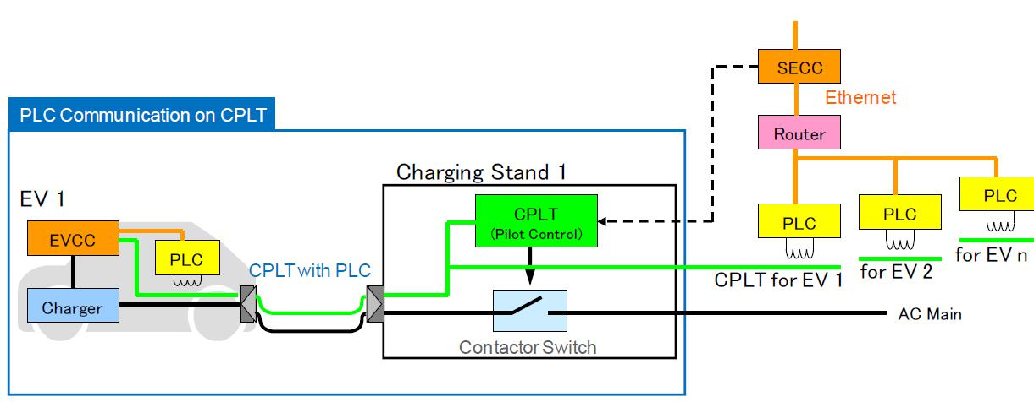

Figure 3. PLC communication on Control Pilot Line (CPLT) [4]

A commercial solution will be the INSYS Power line Green PHY that provides the communication connection between the EVSE controller and the EV. The data stream will be modulated to the pilot line of the charging cable as per ISO 15118-‐3.

The INSYS Power line GP is easily connected to the EVSE controller via Ethernet cable as shown in Figure 4.
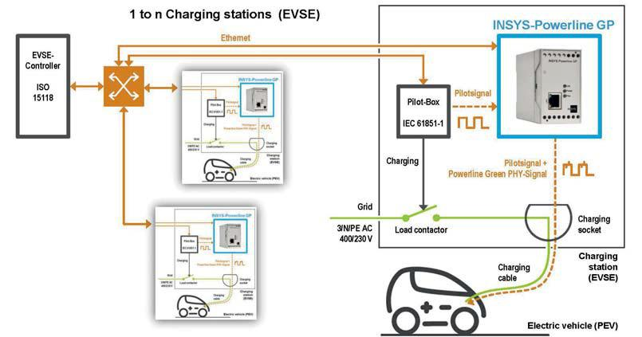

Figure 4. The INSYS Power line GP as a commercial solution [5]

FP7-‐314151 EMERALD Project Page 15 of 20
The V2G interface according to ISO/IEC 15118

4. Interaction between V2G and the electric grid

In order to establish the interaction between the EVs and the electric grid, there are different alternatives [6].

One alternative is the IEC 62056 DLMS/COSEM standard [7] for the communication of the smart metering interface of the EVSE with a central management system. DLMS/COSEM transactions generally consider the smart metering entity as a server and the grid control center as a client. The information is required by a query through a web service. The presently published standard does not contain EV specific objects, the required DLMS/COSEM object extensions was done in PowerUp project [6] for performing the interaction with the V2G interface.

Another alternative is to use the Open Charge Point Protocol (OCPP) for the application layer messaging to the grid control center [8]. OCPP is based on an XML information schema. The standard makes use of Simple Object Access Protocol (SOAP). SOAP is a framework which makes it possible to send messages between components over the internet. The advantage of SOAP is that the facilities for sending and receiving messages are covered by the standard. This makes rapid implementation possible.

A third alternative is to use the IEC 61850 protocol [9] for application layer messaging to the grid control center that is used in Distributed Energy Resources (DER). The IEC 61850 interface has been designed for managing energy flows between renewable electricity resources and power users. While the presently published standard does not contain EV-‐specific objects, a proposed EV-‐specific extension has been published in IEC Technical Report 61850-‐90-‐8 [10], which enables interaction with the ISO/IEC 15118 based V2G interface. This approach represents therefore a realistic alternative to the V2G-‐DLMS/COSEM and V2G-‐OCPP interactions.

FP7-‐314151 EMERALD Project Page 16 of 20
The V2G interface according to ISO/IEC 15118

- EMERALD approach using ISO/IEC 15118 Value Added Services

- Added value services over ISO/IEC 15118

ISO/IEC 15118 defines a use case named “Value Added Services”. The objective of this use case is to allow information exchange between the EVCC (Electric Vehicle Communication Controller) and SECC (Supply Equipment Communication Controller). These optional services may connect to the local network domain (EVSE) or the internet using IP protocols.

- Emerald approach

A service that could be included as an examplein the specification is the “internet access” used by the EVCC to access the Central Point via ISO/ IEC 15118.

The document “Road vehicles — Vehicle-‐to-‐Grid Communication Interface” — Part 2: Network and application protocol requirements, Annex D.1 “Value Added Service selection” shows an example of

how the selection of VAS can be implemented. The following assumption is made: EVCCestablishes Internet Access with the protocols HTTP and FTP, if offered.

First, the EVCC sends a ServiceDiscoveryRes message to the SECC. In this example SECC offers AC and DC Charging, Internet Access, Certificate handling. The offered payment options are Contract and ExternalPayment.

Next, the EVCC requests the details for Certificate and InternetAccess using the ServiceDetailsReq. The response shows that the SECC offers internet access via HTTP using port 80 and via HTTPS using port 443, therefore the EVCC is not allowed to use FTP (Parameter Set ID = 1 or 2) but it can use HTTP or

HTTPS.

Finally, EVCC requests the desired services using the PaymentServiceSelectionReq.

- Fraunhofer example

Fraunhofer ESK is developing underlying communication methods for a uniform energy management system for power grids and electric vehicles. ESK researchers will demonstratehow the charging station serves as an interoperable node between the e-‐vehicle and the network control center using the ISO/IEC 15118 and IEC 61850 standards.

The reference system is intended to help charging station, e-‐vehicle manufacturers and grid operators implement the communication standards and test their products for standards compliance.

FP7-‐314151 EMERALD Project Page 17 of 20
The V2G interface according to ISO/IEC 15118
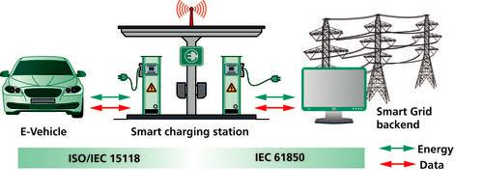

Figure 5. Fraunhofer ESK demonstrating vehicle-‐to-‐grid communications based on ISO/IEC 15118 and IEC 61850 standards.

Value-‐added services based on IEC 15118. The requirement for digital communication before, during and after charging—not just for the charging process but also for vehicle authentication, automatic time-‐delayed charging, dynamic billing models or other services—led to the creation of the ISO/IEC 15118 standard.

As part of the SmartV2G (smart vehicle to grid interface) research project[11] sponsored by the EU, ESK researchers carried out a thorough technology analysis and subsequently developed an enhancement of the ISO/IEC 15118 standard to effect communication between the charging station and the e-‐vehicle. They then tested the interaction of the individual components using the HomePlug Green PHY transmission technology together with IPv6.

FP7-‐314151 EMERALD Project Page 18 of 20
The V2G interface according to ISO/IEC 15118

6. Conclusions

The implementation of the V2G according to IEC/ISO 15118 to establish the bidirectional communication between the electric vehicle and the grid operator is one of the crucial steps in the smart grids. The IEC/ISO 15118 standard has a lot advantages as that this communication makes it possible to dynamically respond to changes in grid condition. The interface of communication is commonly indicated as V2G and includes a wide range of demand-‐responsive energy services as the contribution in the stability grid, peak load leveling of the grid and allowing some kind of saving to electric vehicles owners.

The main problem in the implementation of this standard is the implication of electric vehicle manufactures to embedded a PLC with the requirements of IEC/ISO 15118. In the case of the EVSE controller there is actually commercial solution that provides the communication with the EV.

This white paper could be a reference document to establish a basic architecture over this standard.

FP7-‐314151 EMERALD Project Page 19 of 20
The V2G interface according to ISO/IEC 15118

7. References

- IEC 61851-‐1, Electric vehicle conductive charging system ― Part 1: General requirements

- http://www.iso.org/iso/catalogue_detail.htm?csnumber=55366

- http://www.jsae.or.jp/e07pub/yearbook_e/2014/docu/28_industry_standards.pdf

[4]http://www.power-‐up.org/wp-‐ content/uploads/2012/07/PowerUp_D3.2_Final_V2G_Architecture.pdf

[5]http://www.insys-‐icom.co.uk/bausteine.net/f/10599/DS_en_INSYS-‐Powerline-‐ GP_130715_eBook.pdf?fd=0

[6]http://www.iaria.org/conferences2012/filesSECURWARE12/Electric_Vehicle_Charging_Infrastructure _Keynote%20RainerFalk.pdf

- http://dlms.com/documents/ARCHIVE/Excerpt_GB6.pdf

- http://www.openchargealliance.org/?q=node/4170

- https://en.wikipedia.org/wiki/IEC_61850

- http://blog.iec61850.com/2012/06/iec-‐61850-‐90-‐8-‐object-‐models-‐for-‐e.html

- http://www.smartv2g.eu/

FP7-‐314151 EMERALD Project Page 20 of 20

